1. Write a recursive function that computes the sum of numbers from 1 to n

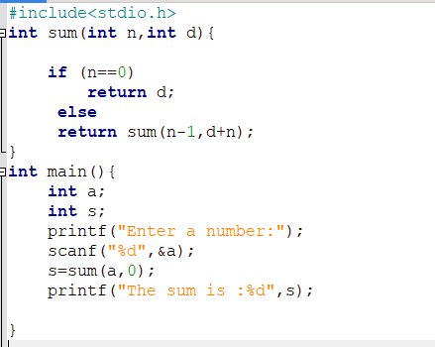

OUTPUT:

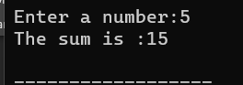

1. Write a recursive function in C to find the nth Fibonacci number.

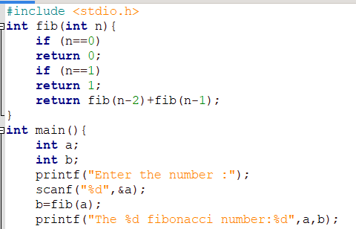

OUTPUT:

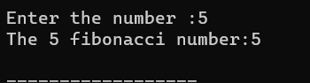

1. Write a recursive function to find the GCD of two given numbers. 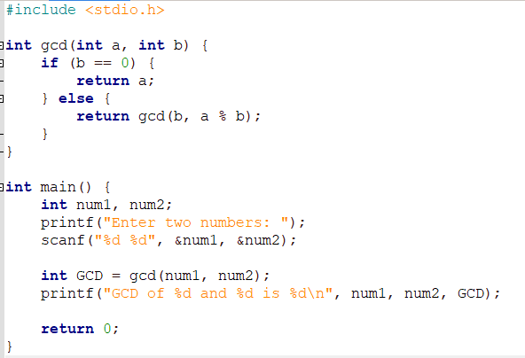

OUTPUT:

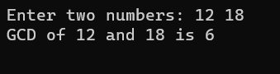

4. Write a recursive function (for each) to print the digits in an integer

a. From left to right

b. From right to left

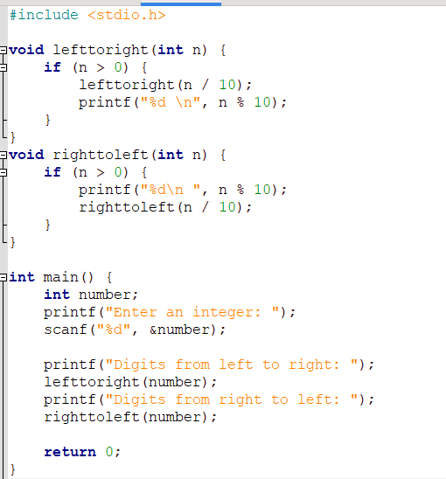

OUTPUT:

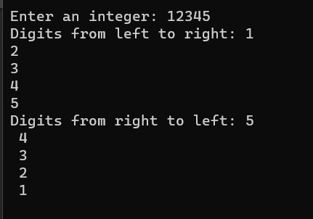

5.Write a C Program to find the product of two numbers using a recursive function.

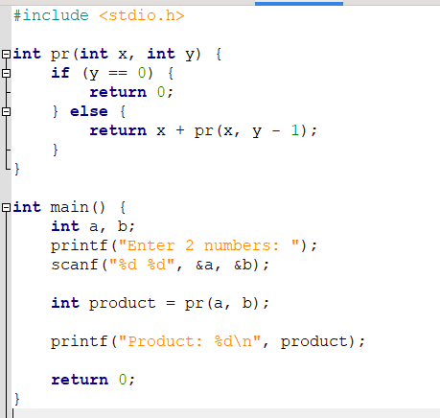

OUTPUT:

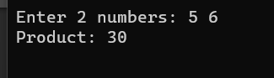

6. Write a C Program to find the value of nx using a recursive function, where n and x are integers.

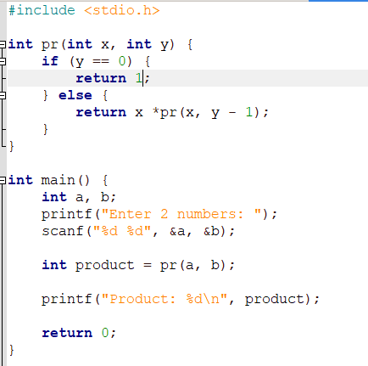

OUTPUT:

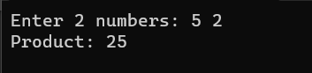

7. Write a C Program to convert a decimal number to its binary equivalent using a

recursive function.

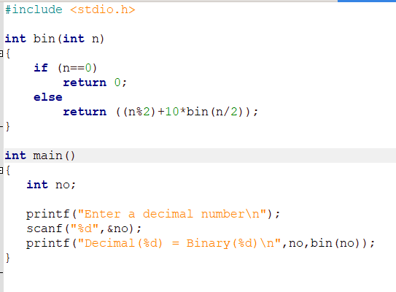

OUTPUT:

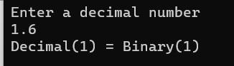

8. Write a C program that reads 10 integers from the user and stores them in an array.

Find the largest value in the array and print it.

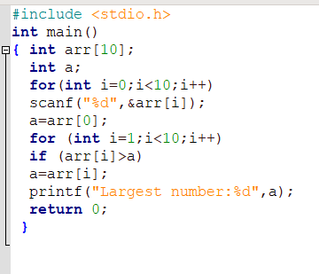

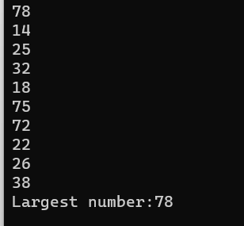

9. Write a C program to interchange the largest and the smallest number in the array.

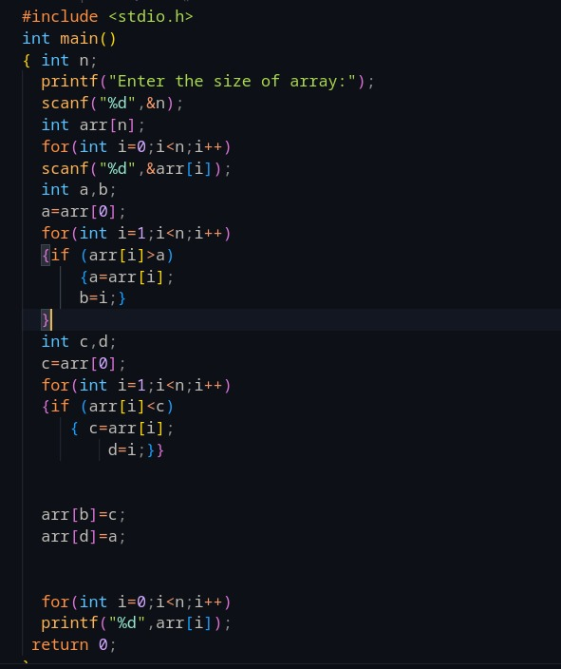

OUTPUT:

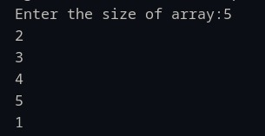

10.Write a C program to find the second biggest number from an array of n numbers.

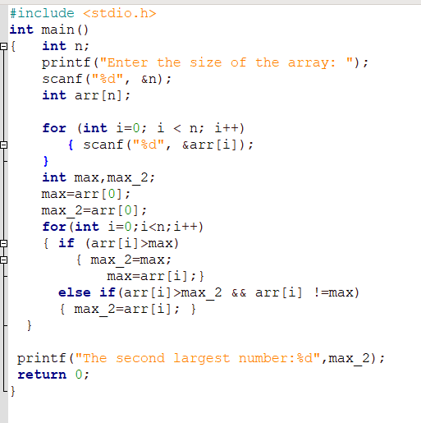

OUTPUT:

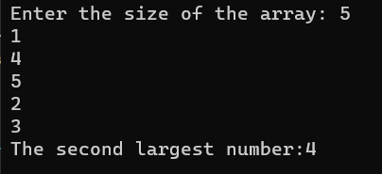

11.Write a C program to find whether the array of integers contains a duplicate

number. If it’s there, print the position of duplicate numbers.

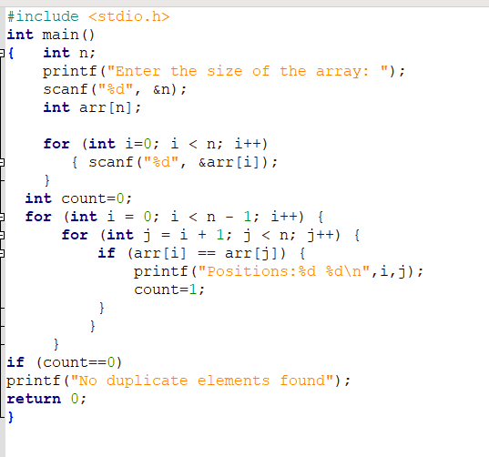

OUTPUT:

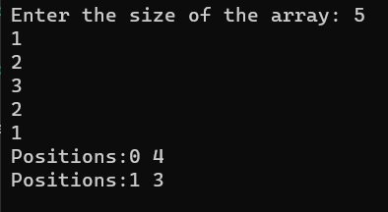

12.Write a program to find out whether a particular element is in the integer array

using Linear search.

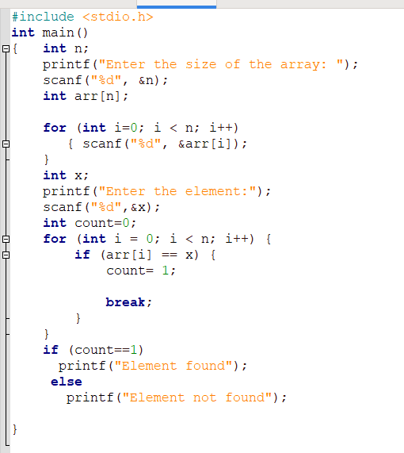

OUTPUT:  
